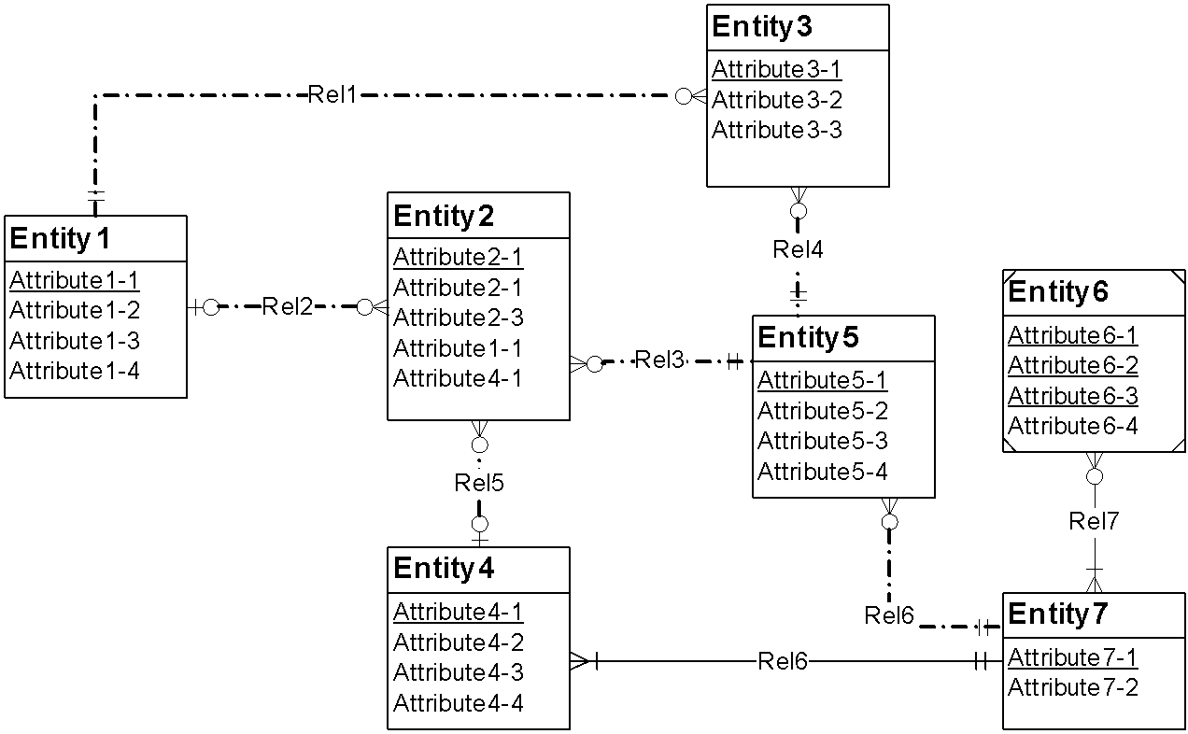

Rel 5 has Redundant FK Rule violation.

Identifying Relationship rule violation between Entity 4 and 7.